The Werewolves Game

Team members: Shujing Lin, Junwei Zhou, Shuyi Qi

Andrew id: shujingl, junweizh, shuyiqi

**Project Description:**

The Werewolves is a popular board game consisting of usually 6~18 players. The players are divided into two camps: bad camp---with werewolves, and good camp---including civilians and the special characters. The goal for the werewolves is to conceal their identities and eliminate players from the good camp. The goal for the good camp is to find all the werewolves and eliminate them. In this project , we will focus on the 6-player version of the game. There will be 2 werewolves, 2 civilians, and 2 special characters (prophet and guard). The good camp will win if they eliminate all the werewolves. The bad camp will win if they eliminate either all the civilians or all the special characters.

We are planning to build a live online game website for this classic board game, where players can create their own rooms and play the game online. A registered player could either join an opening room to play with other random players or join a room through a shared URL. In the game room, the server will control the procedure of the game, and players will be able to communicate with each other and vote.

**Key features of the website include the following:**

* Login / Register
* Create a game room / Join a game room
* A visualization of players in the game (will change colors or add symbols to indicate different states)
* Live chatting among players (enable or disable chat to control who can speak)
* Server-generated messages to advance the game
* Timer countdown to control length of players’ time to speech/vote

**Technologies:**

* Django (server that handles and authenticates requests)
* JavaScript & SVG (browser-side operations and render view of game)
* Bootstrap(easier for implementing the layout of the page)
* HTML/CSS (lay out and style page)
* Ajax (asynchronously send and retrieve data from server without interfering with the page)
  + Good for chat features
* AWS EC2

*For a more detailed description of how users will play the game, we have added an appendix to this document.

Mock-ups

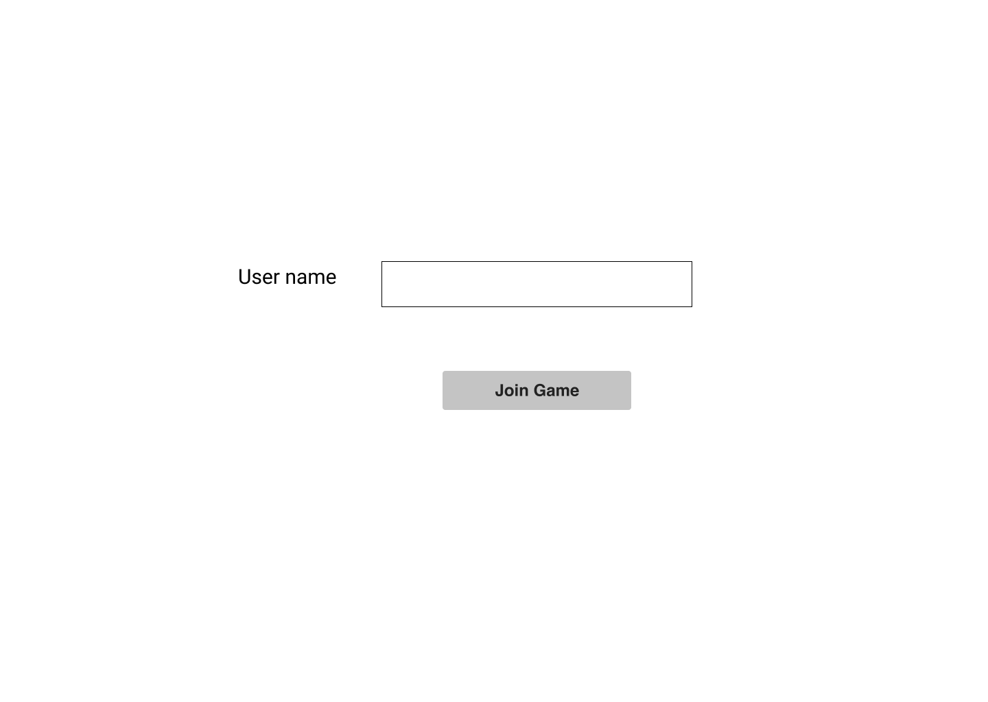

Create a username and join the game

Wait until there are 6 players to start the game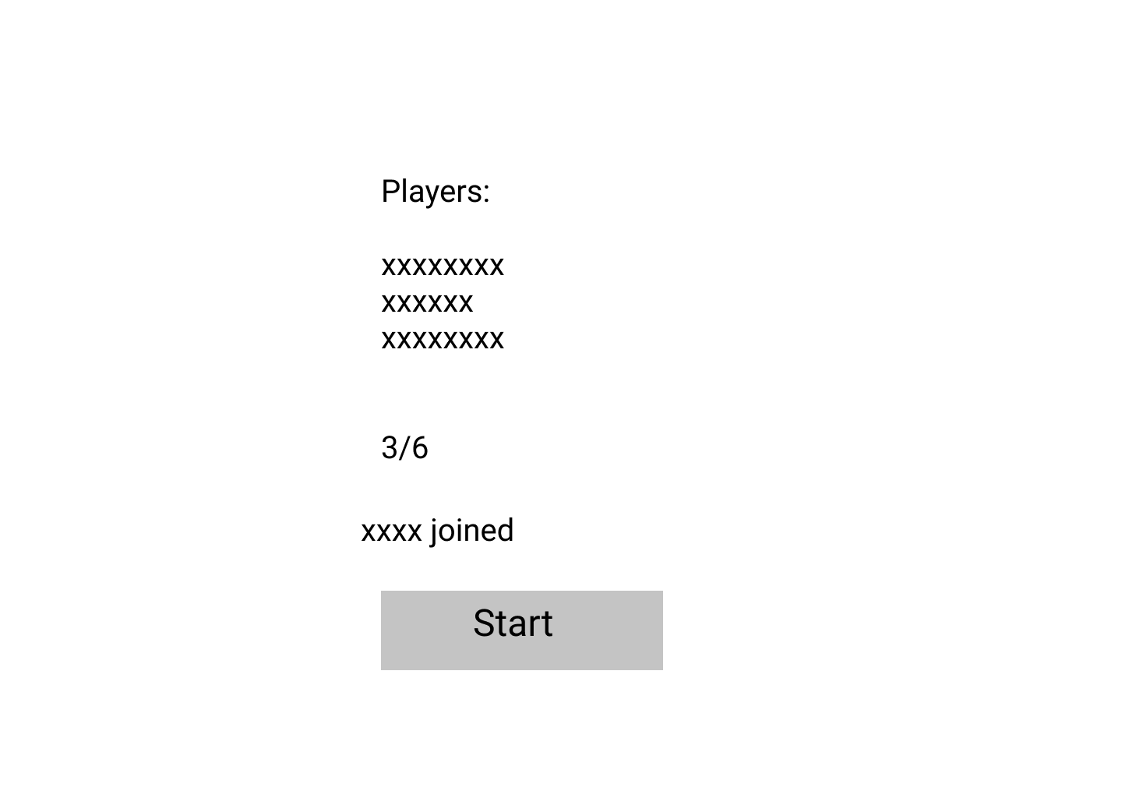

Werewolves’ view. Can see player’s identity and teammates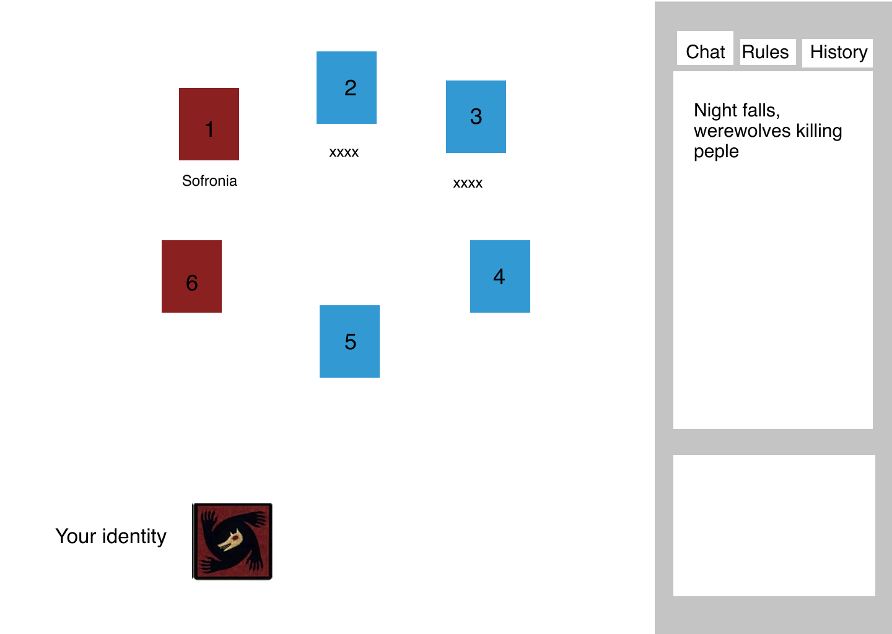

Werewolves can chat among each other(chat only visible to the werewolves) and choose a player to kill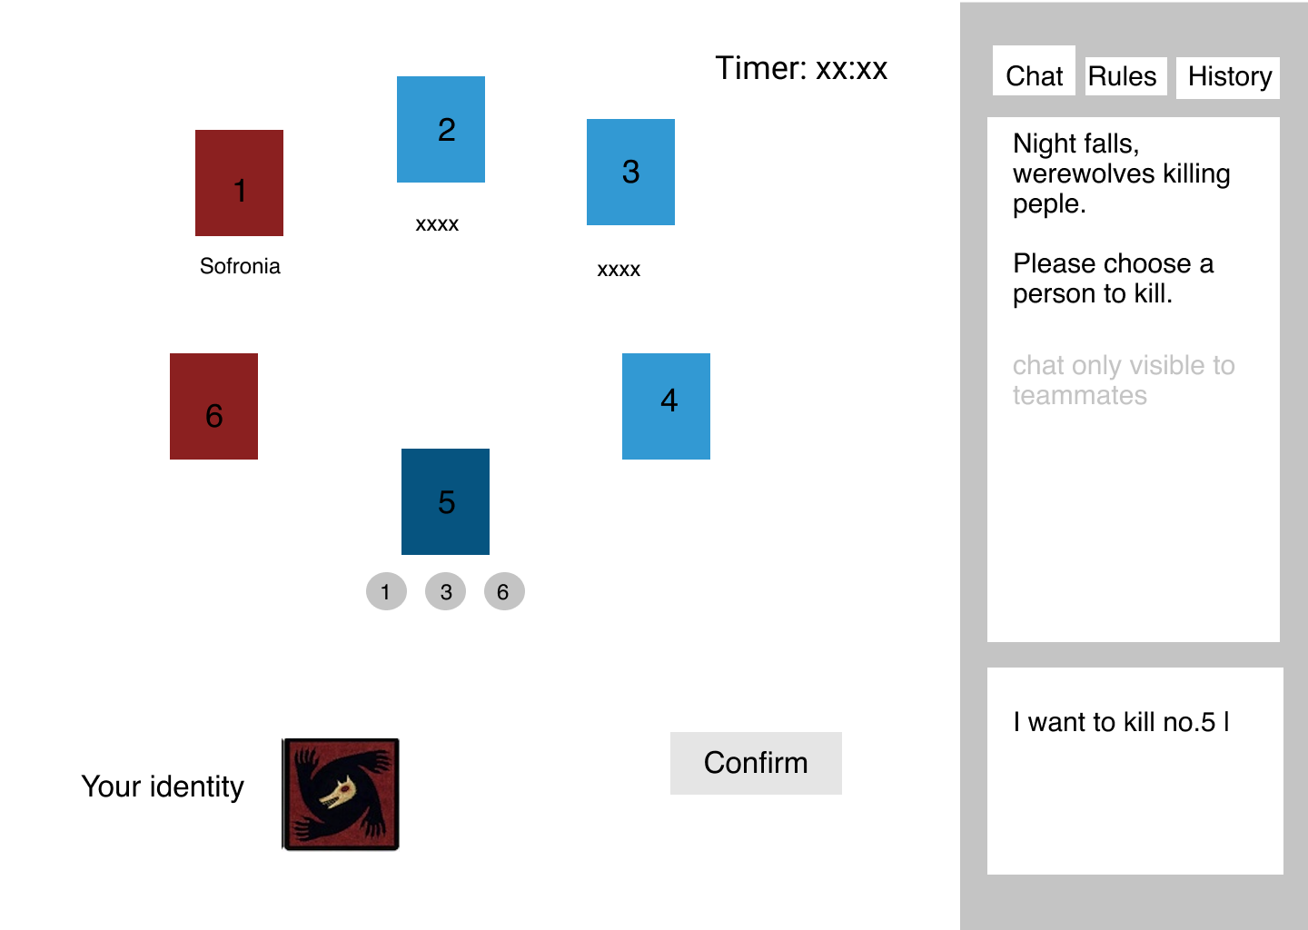

When it is daytime, the server will randomly pick a player and players will speak one by one. (there will be a star indicating who is speaking)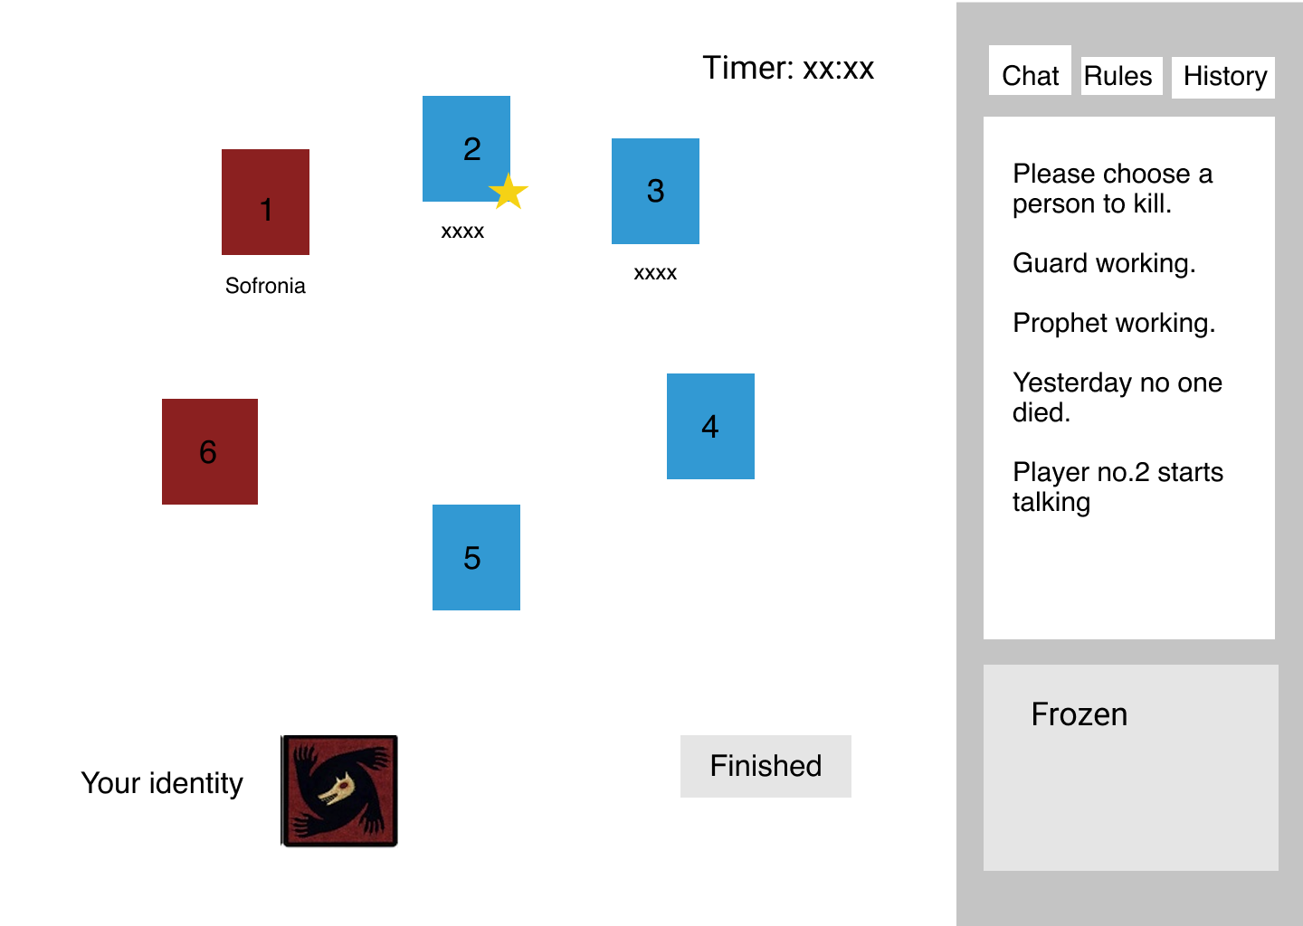

Players vote for the suspects after everyone finishes their speech 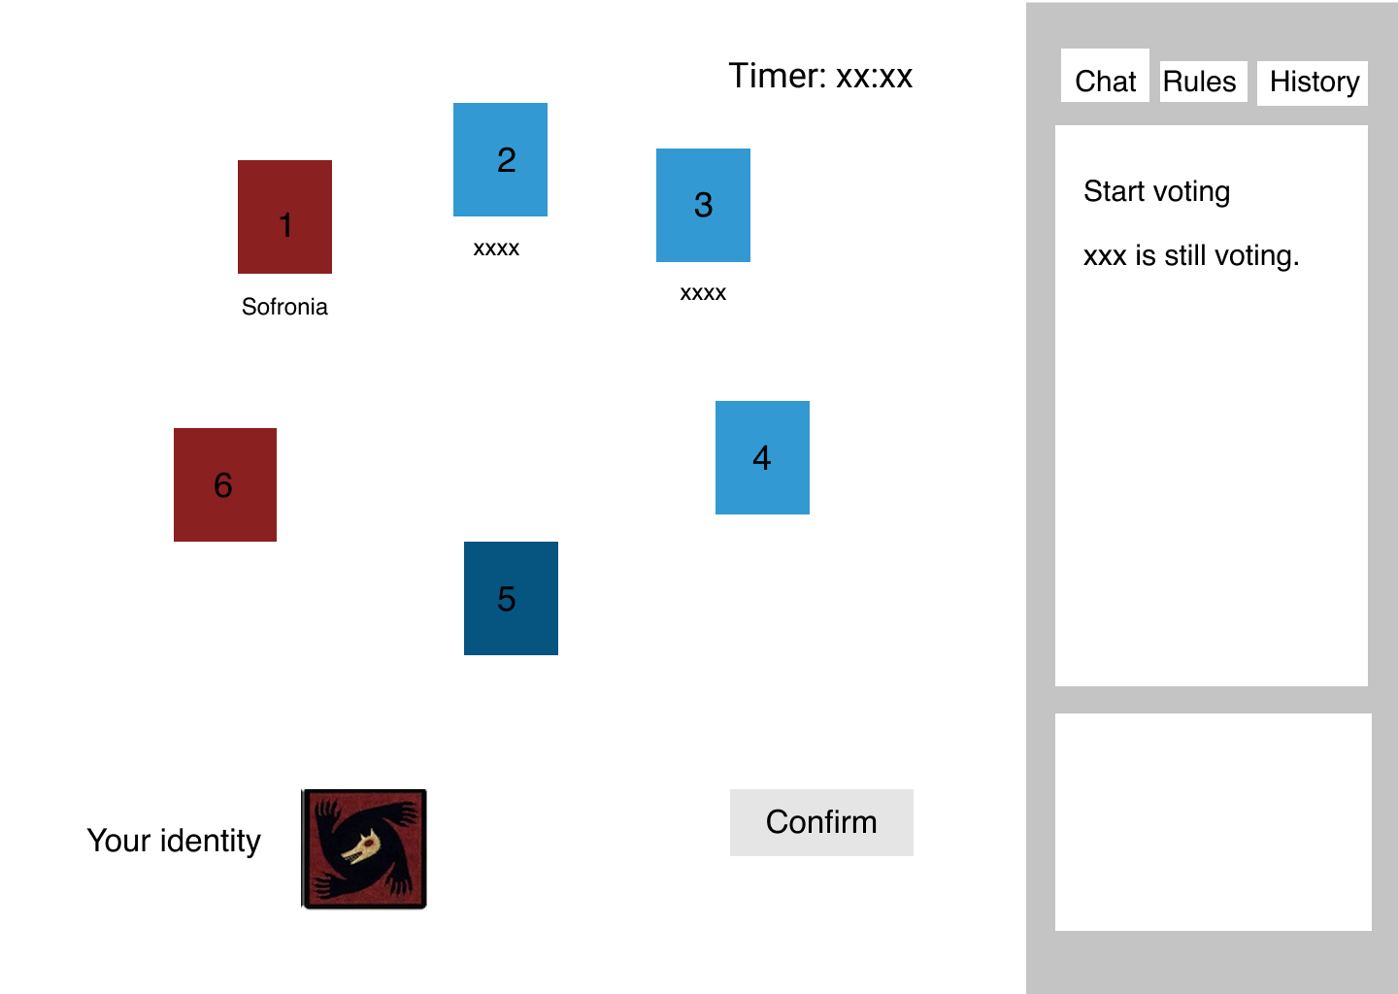

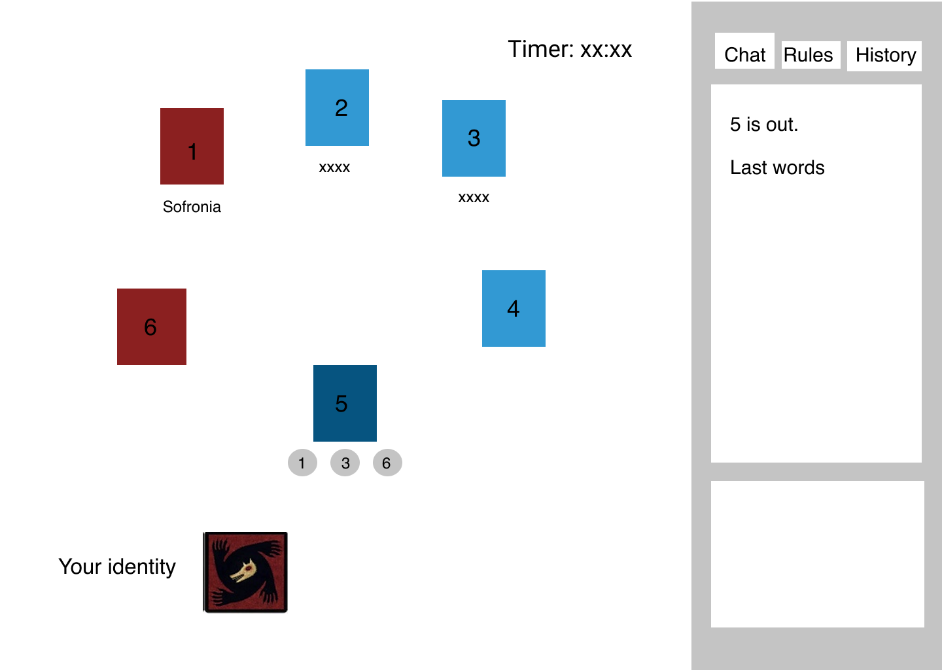

Who gets the most votes is eliminated. Canvas will show who votes for this player.

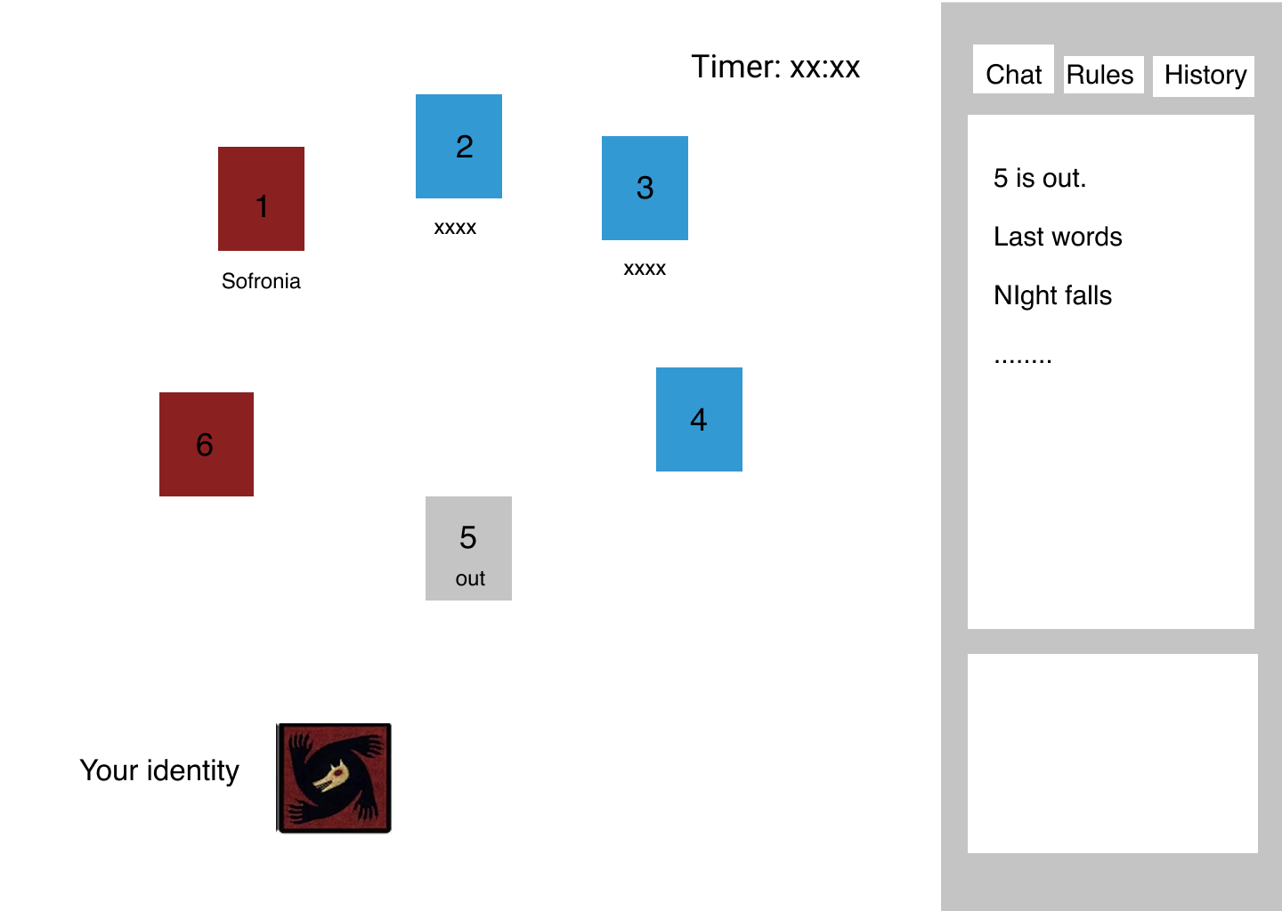

Canvas indicates who is out. A new round starts.

Appendix

### The Characters:

Villagers

Villager is the character with the least power in this game. They must sleep at night and will participate in speech/voting during the day. Their goal is to vote out the wolves.

Wolves

Each Wolf knows the other wolves in the game. They have a discussion about strategies at the beginning and agree on attacking one player every night.

Special Characters

The Prophet can look at the identity of one player every night. They may only know if the player is a wolf or a good person. They may not know if a person is a villager or a special character.

The Guard is a Villager that chooses another player to defend at night. That player is immune to any attack a night. The Guard can choose themselves, but not the same person twice in a row.

### Game Procedure:

1. Night:
   1. Wolves:
      1. Discussion (only during the first night)
      2. Pick a victim
   2. Guard (if still alive):
      1. Pick a player to defend (can’t pick the same person twice in a row)
   3. Prophet (if still alive):
      1. Pick a player
      2. Being told about whether the player is wolf or not
2. Day
   1. Announcement
      1. All players will be told about what happened last night
      2. Or the winning of the game
      3. The first player killed by the wolves at night will make a speech
   2. Speech
      1. Every player speech
   3. Vote
      1. Every player vote for the wolf
      2. The voted player will make a speech
3. Repeat steps 1~2 until we hit one of the winning/losing conditions